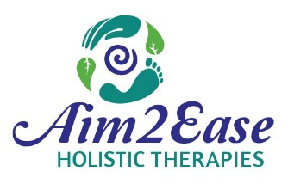Contract for Services
About Holistic Therapy
Holistic Therapies are noninvasive complementary modalities provided through natural processes. Therapies are intended to help the body to relax and achieve a more balanced state which supports the body to function optimally. Additional general information about specific modalities offered and what to expect are available at aim2ease.com.
Participants are encouraged to seek further information from multiple sources and to resolve concerns, Participant is solely responsible for their decision regarding participation and own health care.
Potential impact of therapies
1. Shifts in biochemical and physiological status of the body.
2. Shift in nervous system to reduce tension and stress and provide relaxation.
3. Improve movement in energy systems in and around the body.
4. Promote balance and normalization of the body which supports natural self-healing.
5. Stimulated circulation resulting in delivery of oxygen and nutrients to cells.
6. Physical, mental, and/or emotional shifts vary and may be immediate, cumulative, or up to months later.
7. There are no guarantees as to reactions or results.
Holistic Therapies are not a substitute for medical care; Practitioner
1. is not a doctor; does not practice medicine.
2. does not diagnose or treat for a specific illness.
3. does not prescribe or adjust medication.
4. recommends consulting a physician or other qualified medical specialist for specific ailments.
5. may refuse services or request medical clearance for certain situations.
Privacy
Personal information, given at intake and all subsequent communications, is taken to assess general health and used for preparation and provision of services. Personal information will be safeguarded and not be disclosed without written consent.
CANCELLATION & LATE START POLICY
If you need to reschedule or cancel your appointment, please communicate at least 48 hours in advance. Less than 24 hr cancellation will be charged a $20 fee. Repeat cancellations and/or “no show” will require pre-pay for future sessions. A late start due to tardiness will result in session ending as scheduled unless an adjustment is pre-arranged.
Informed Consent
I have informed the practitioner of known medical conditions and answered all intake assessment questions to the best of my ability. I agree to update practitioner of changes to physical, mental or emotional health. Practitioner is not liable for problems that I perceive as attributed to therapies.
By signing this form, I acknowledge understanding information on this form, the nature of the therapies, and freely elect to receive the therapies selected. I understand I may stop the session at any time.

